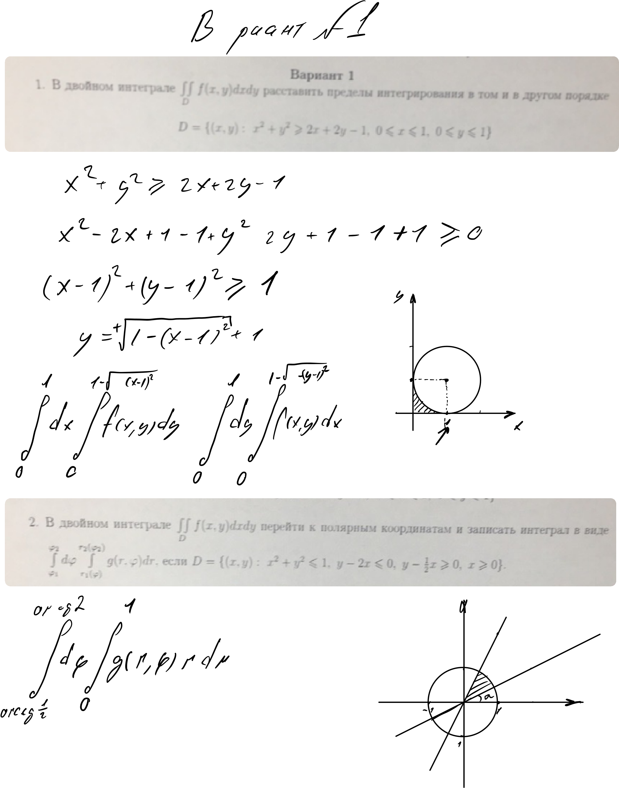

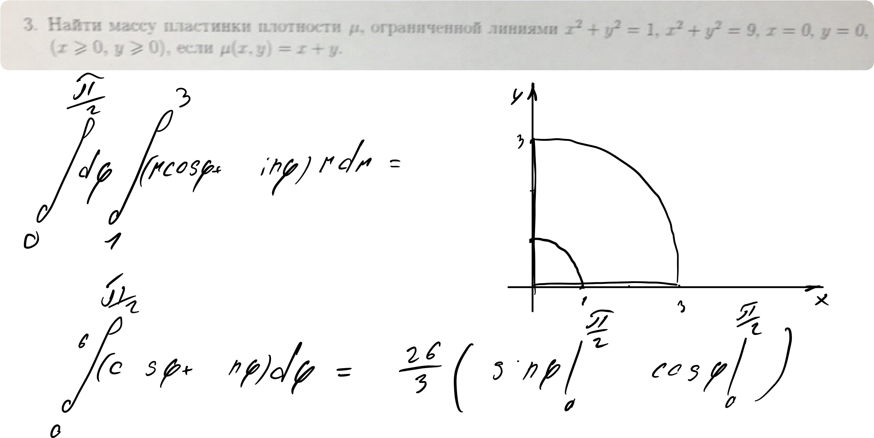

И

я

ли

оĸт

~~Ё~~

К

e

Afterlif

т

о

~~0~~

0

1

1

х



4

~~53~~

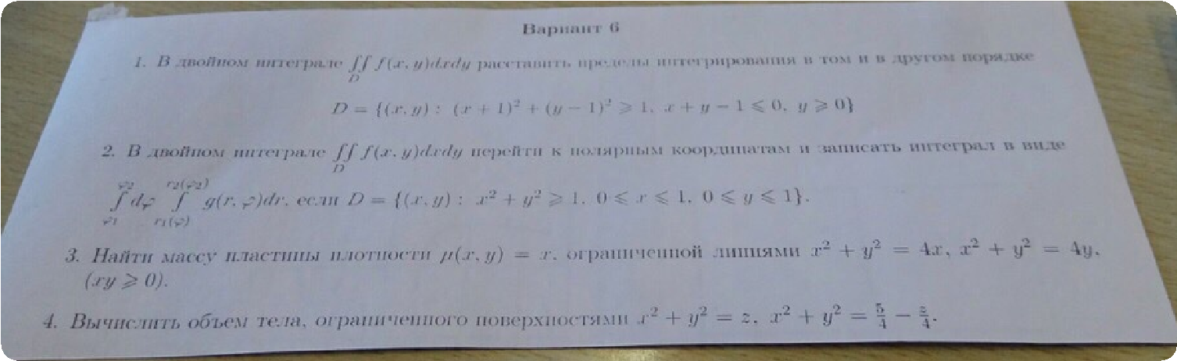

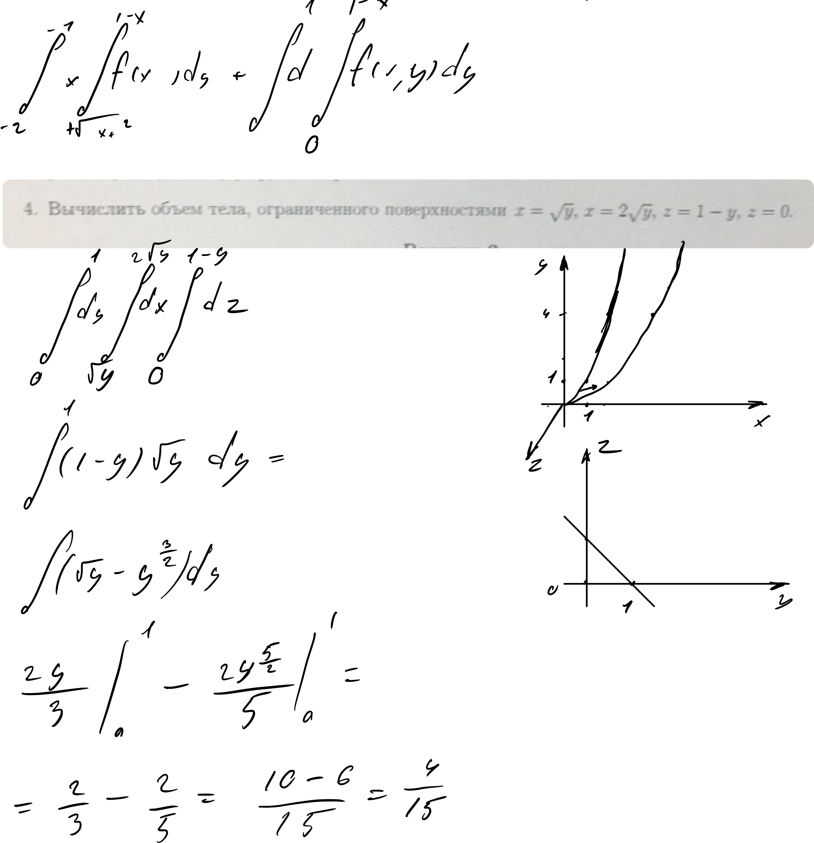

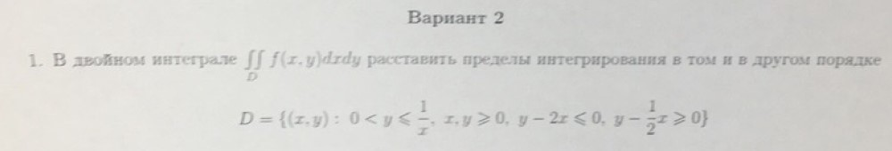

н~~е~~т

А

iii

~~К~~

Г

х

~~г~~

I

~~I~~

I

iffier

И

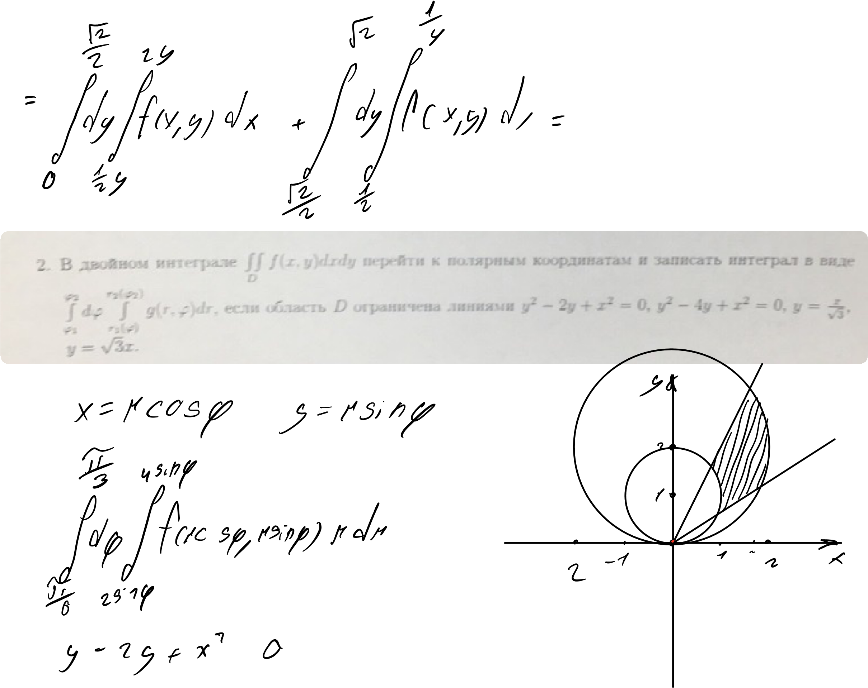

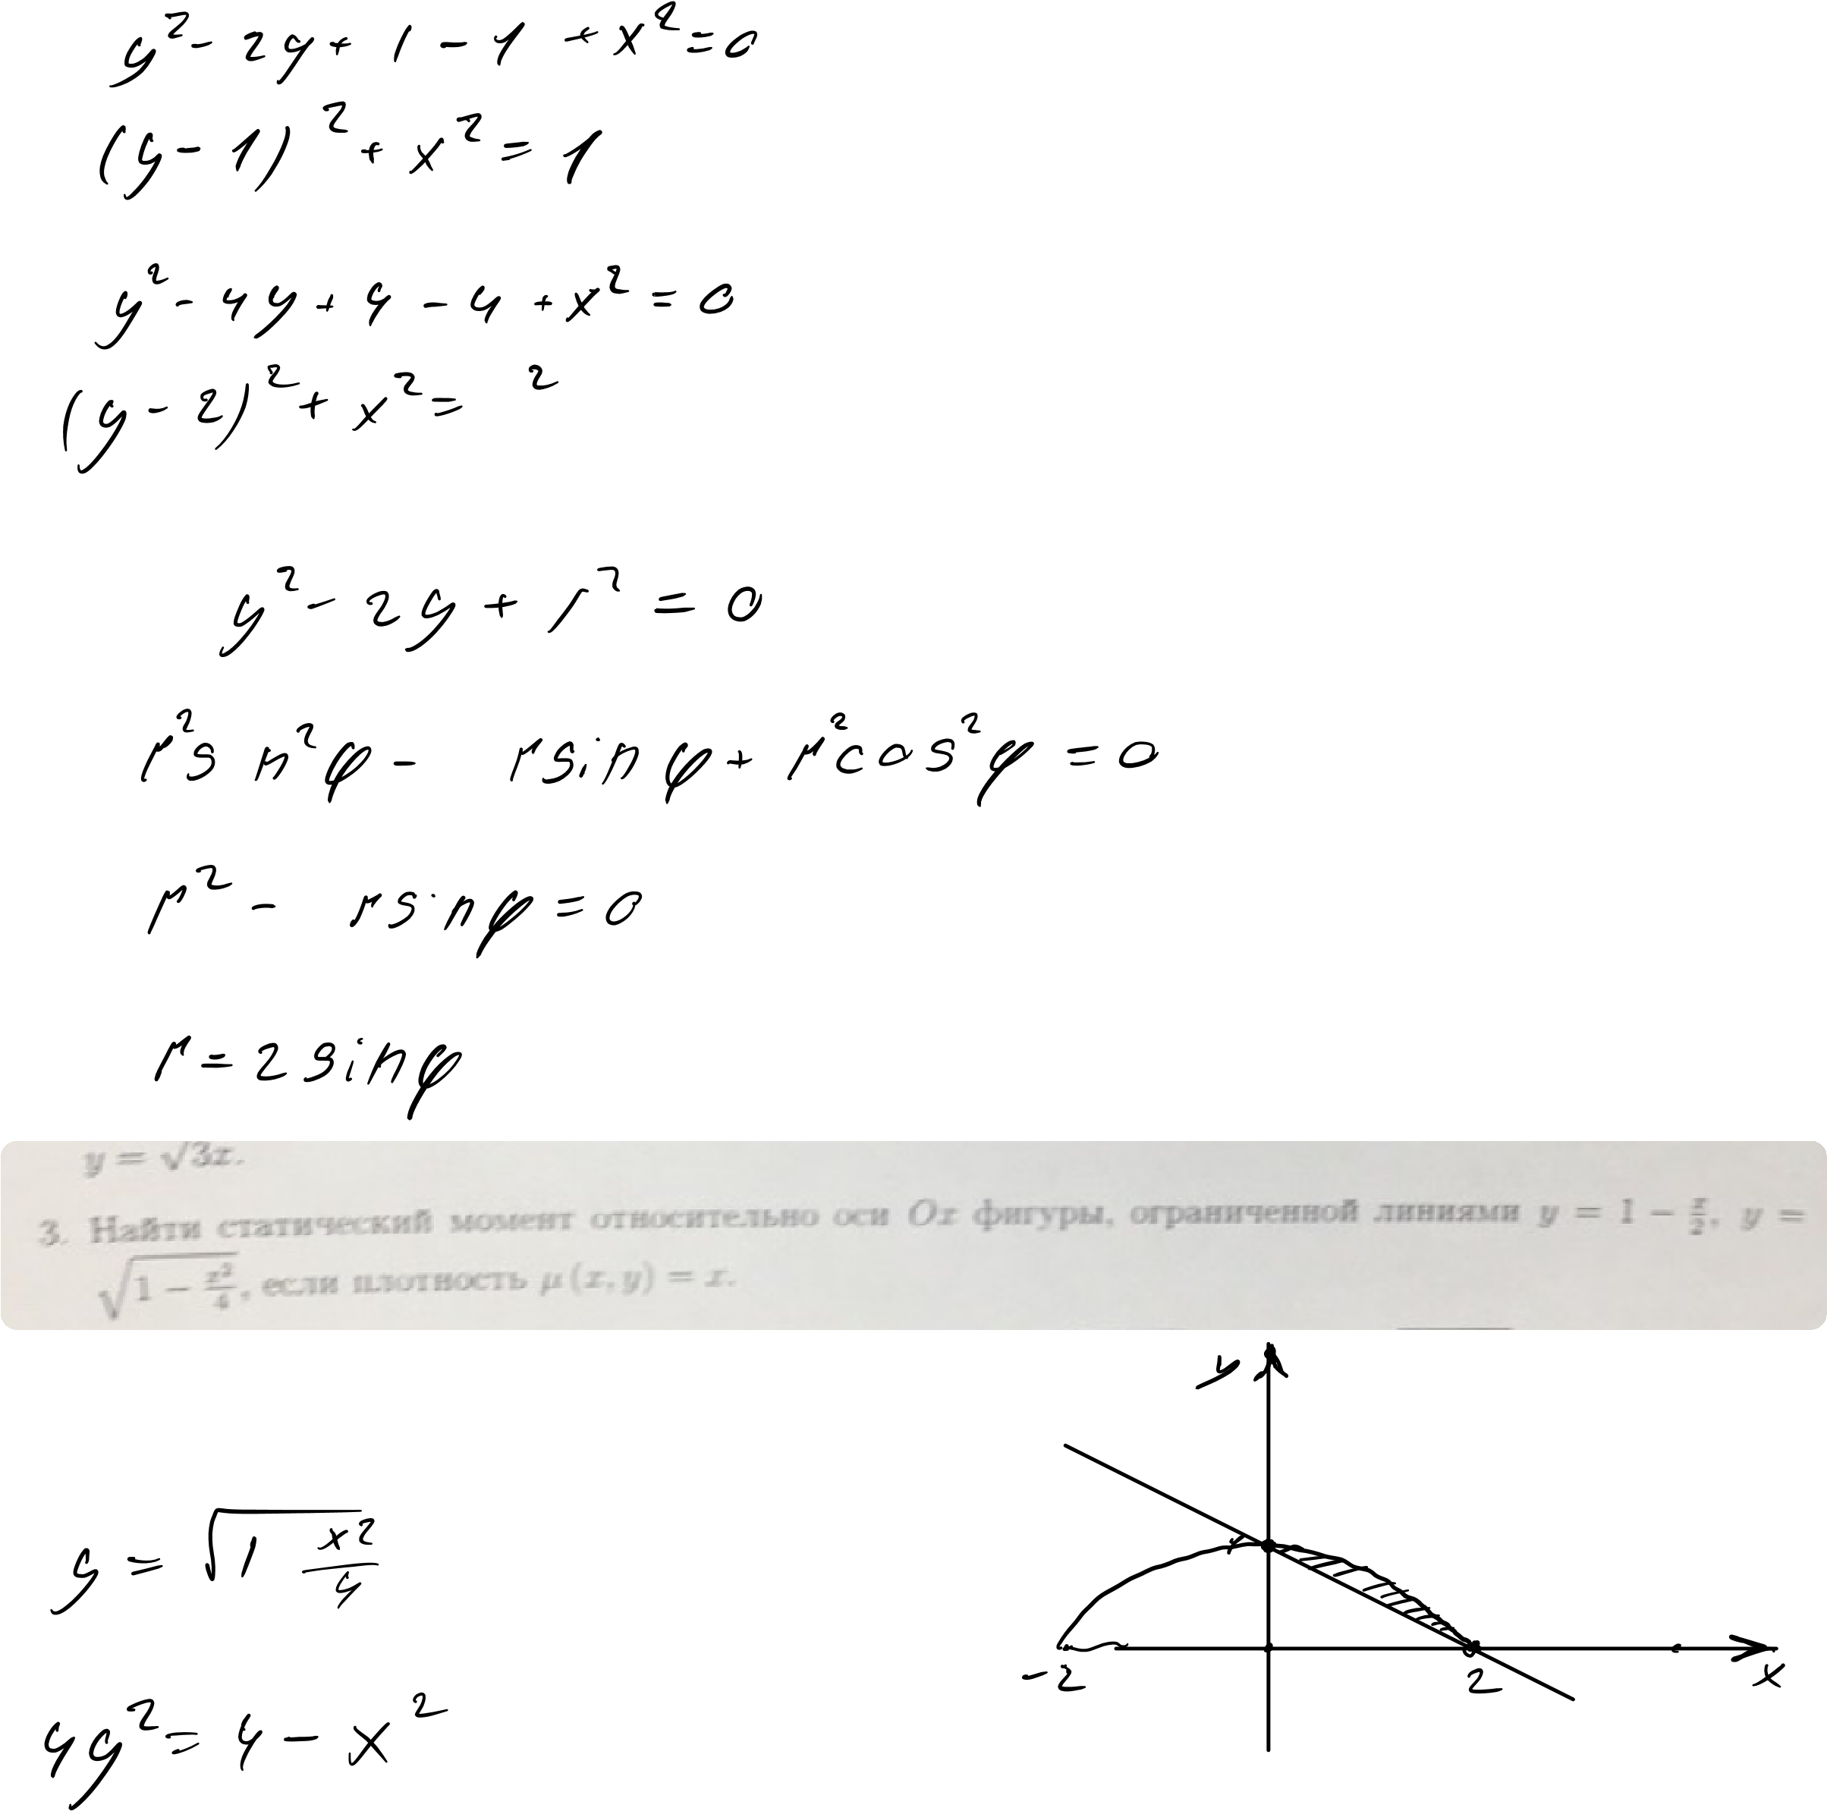

~~2~~7 I ~~4~~.1~~1~~ ftp.x~~s~~

Й~~о~~си1ть µРж~~д~~

# ~~Н~~ЁЁ E ~~E~~ d

## ЁТи1 ~~ши~~ны

